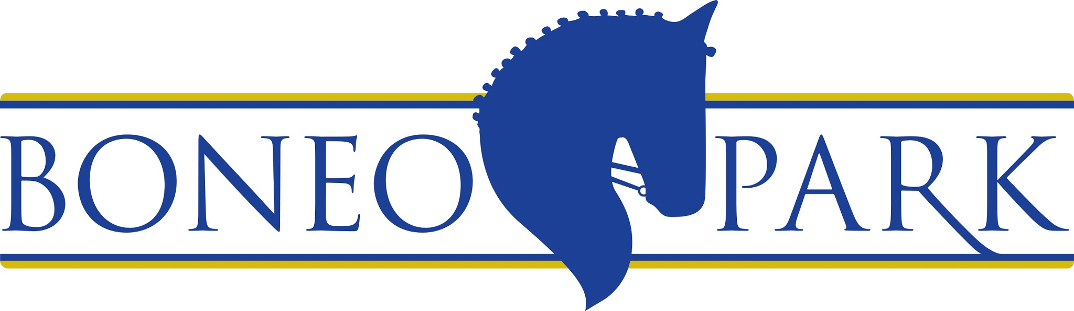

TRADE STAND OPPORTUNITIES
AT OUR MONTHLY EVENTS

ABOUT BONEO PARK

Boneo Park is Victoria’s most progressive and prestigious equestrian venue, dedicated to developing the next generation of our country’s top equestrian athletes. Situated in the picturesque Mornington Peninsula, just south of Melbourne, this first­ class venue offers outstanding competitive opportunities bringing together athletes from the junior, young rider and international ranks from all over Australia. International classes for dressage, show jumping and para equestrian disciplines, held as part of the Boneo Classic provided qualifying opportunities for the Olympic Games and World Equestrian Games.

Boneo Park holds several large scale events throughout the year in addition to the Classic which attract Australia’s best equestrian competitors to our facility. These events include the Boneo Park SJ Cup and Spring CDI in September and the Boneo Park Carnival in November.

ABOUT BONEO PARK’S MONTHLY EVENTS

In addition to these large scale events, Boneo Park hosts smaller monthly showjumping and dressage competitions as well as four interschool combined training days each year. These events continue to grow in demand and are amongst the biggest EA dressage and showjumping events in the state.

Boneo Park’s monthly competitions have an attendance of 250 – 400 people; this includes
riders, family and friends of riders and spectators. Boneo Park has a reputation for holding professional events and competitors travel from all over Victoria and Interstate to compete.

TRADE STAND OPPORTUNITIES

Boneo Park has opportunities for business owners who want to come and display and sell their product to our event attendees. These packages are available for each of our monthly dressage and showjumping events as well as our one day interschool competitions. Please see our event calendar on our website for event dates.

COST

$220 / day inc GST

PRODUCT OPTION

We also have a contra option whereby you provide Boneo Park with $500/day worth of goods in kind that we can use as prizes in return for your trade space.
Please note there must be a minimum of 5 separate items

INCLUSIONS AND CONDITIONS

- Includes two phase power
- Cost is for space only, whereby you bring your own stall
- Marquees are available to hire for an additional cost
- All companies must have proof of current public liability insurance

For further enquiries or to book in for one of our events please contact fiona@boneopark.com.au

